- Do not edit/delete any heading or section with red text.
- Type /paste you answers in relevant sections (below Final Answer (in all questions , Approach (wherever required ) and Charts & tables (wherever required)) of the solution
- Link to submission guidelines
- Please note that submission not following the guidelines will not be accepted

OBJECTIVE QUESTIONS

Question 1: What is the total no. of tables present in the data?

Solution:

Final Answer (if any):
There is 1 table present in the data, located on the Data sheet.
Approach (if any):
The entire dataset is one table of data in data sheet which is original data.
Charts & Tables (if any):
NA

Question 2: What is the total no. of attributes present in the data?

Solution:

Final Answer (if any):
There are 35 attributes present in the data.
Approach (if any):
Used =COUNTA(A1:AI1) function to calculate the number of attributes and answered the question in cell AK2 in data sheet

Charts & Tables (if any):
NA

Question 3: The data consists of some inconsistent and missing values so ensure that the data used for further analysis is cleaned.

Solution:

Final Answer (if any):
Checked duplicates in the Dataset through Remove Duplicates option. Used Trim function to remove extra spaces and used Proper function to Format the first letter of each cell text data for better clarity where ever required. Populated missing values with “Unknown” or 0 where ever required for better and accurate analysis. Used all the formula in the (Cleaned Data) sheet by creating new columns and in the first row and then populated the formula in the rest of the columns. Then copy and pasted the populated formula data as Values and removed the duplicate columns for the same data. Added borders in the Dataset, Fixed the headers, Centre Aligned the data

Approach (if any):
Formula Used:-
Ctrl+B= Used to highlight all the attribute’s Headers in bold
Trim()= Used to remove extra space in the Guru Name Column
Proper()=Used to Format the first letter of each header cell text data for better clarity.
=if(isblank(C2),”Unknown”,C2 in Chat Status and other required columns
=if(isblank(C2),”Unknown”,C2 in User oncall duration and other required columns which has numberical values

Charts & Tables (if any):
N/A

Question 4: What is the change in daily call volume day by day and also find the average daily call volume.

Solution:

Final Answer (if any):
Created Pivot table to highlight the change in call volume day by day. The average daily call volume is 250.24
Approach (if any):
Change in Call Volume Day By Day- =IFERROR(B15-B14," Unknown Value")
Average Call Volume Daily- =ROUND(AVERAGE(B14:B47),2)
Charts & Tables (if any):
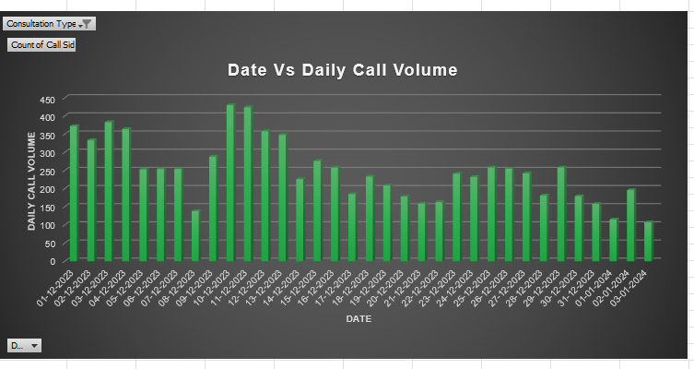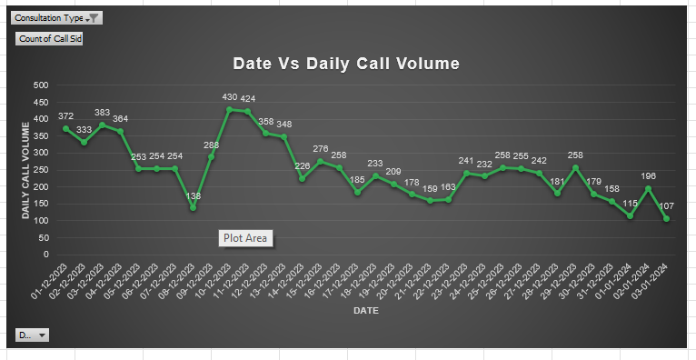

Question 5: Which months experienced the highest and lowest call volumes?

Solution:

Final Answer (if any):
December month has the highest call volumes of 8090 and January has the lowest call volume of 418
Approach (if any):
highest call volumes- =MAX('Q-4 I Objective'!B14:B47)
lowest call volumes- =MIN('Q-4 I Objective'!B14:B47)

Charts & Tables (if any):
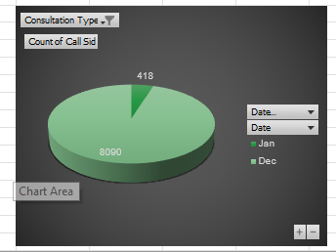

Question 6: What is the total operational cost for that month?

Solution:

Final Answer (if any):
Total operational cost for the month of January is 5360.408 and December has 93786.16295 and total combined is 99146.16295 for both months
Approach (if any):
December Operational Cost- =GETPIVOTDATA("[Measures].[Sum of Astrologers Earnings]",$A$9)-GETPIVOTDATA("[Measures].[Sum of Astrologers Earnings]",$A$9,"[Range].[Month]","[Range].[Month].&[January]")

January Operational Cost- =GETPIVOTDATA("[Measures].[Sum of Astrologers Earnings]",$A$9)-GETPIVOTDATA("[Measures].[Sum of Astrologers Earnings]",$A$9,"[Range].[Month]","[Range].[Month].&[December]")

Total Operational Cost- =B17+B18
Charts & Tables (if any):
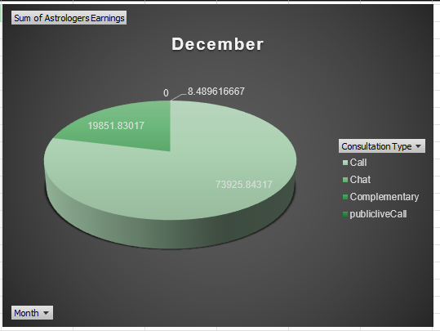

Question 7: What is the average number of calls handled per agent per day?

Solution:

Final Answer (if any):
Average number of calls handled per agent per day is 2.25
Approach (if any):
Total Calls Made- =GETPIVOTDATA("[Measures].[Count of Call Sid]",$A$11)
Total Unique Gurus who Made Calls- =COUNT(A12:A142)
Total Days- =COUNT('Q-4 I Objective'!A14:A47)
Average Calls Per Agent Per Day- =ROUND((D12/E12)/F12,2)
Charts & Tables (if any):
NA

Question 8: How many repeat callers are there, and what percentage of total calls do they represent?

Solution:

Final Answer (if any):
Repeated callers are 1277 and they represent 35.19 percent of the total calls
Approach (if any):
Total Calls Made- =GETPIVOTDATA("[Measures].[Count of Call Sid]",$A$11)
Total Callers- =COUNT(A12:A3640)
Total Repeated Callers- =COUNTIF(B12:B3640,">1")
Total Percentage of Repeated Callers- =ROUND((E11/E10)*100,2)
Charts & Tables (if any):
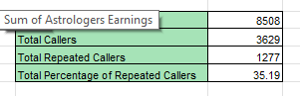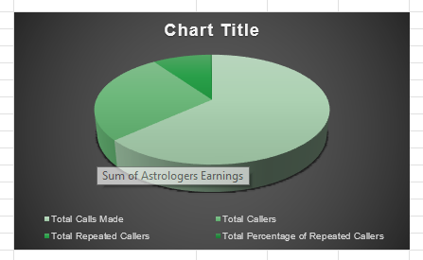

Question 9: What are the total sales generated by the call centre for each product category?

Solution:

Final Answer (if any):
Total sales generated by the Call are 168520.6183, Chat are 45494.68333, Complementary 0 and Public Live Call are 50.597
Approach (if any):
Used Pivot Table to summarize

Charts & Tables (if any):
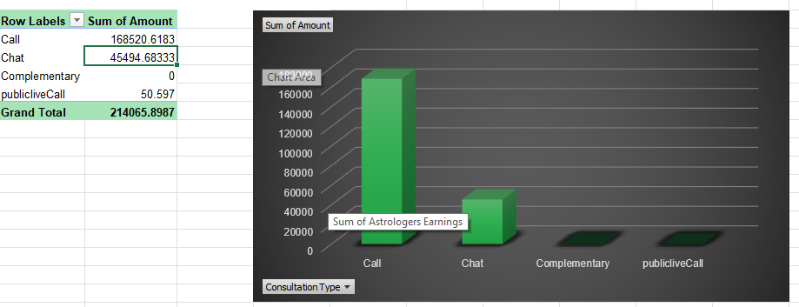

Question 10: How many calls were made for each user ID and guru ID?

Solution:

Final Answer (if any):
Total calls made by User id and Guru ID are 8505
Approach (if any):
Used Pivot Table to summarize

Charts & Tables (if any):
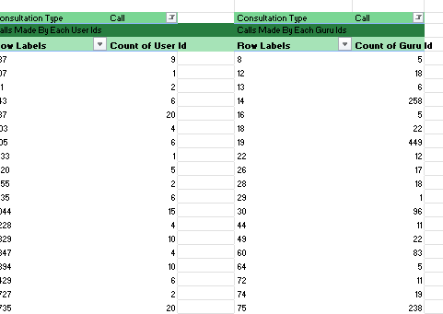

Question 11: What is the correlation between call duration and customer satisfaction?

Solution:

Final Answer (if any):
Correlation between call duration and customer satisfaction is 0.054758181 which is nearest to 0. That means there is no correlation.
Approach (if any):
Correlation Of Call Duration and Customer Satisfaction- =CORREL('Cleaned data'!AM:AM,'Cleaned data'!AN:AN)
Charts & Tables (if any):
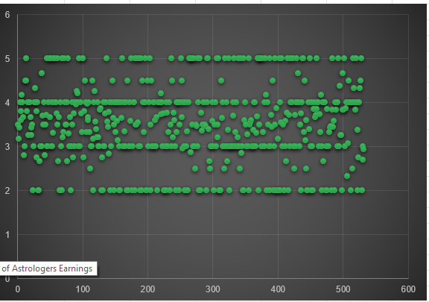

Question 12: Which guru has the highest and lowest customer satisfaction scores?

Solution:

Final Answer (if any):
Tarot Mystical and Astro Pujaa Rai has the highest customer satisfaction score of 7.5 each and Tarot Rittika has the lowest score of 0
Approach (if any):
Sorted the averaging of rating from highest to lowest and extracted the IDs with highest and lowest rating. Made a separate table to highlight the same Ids and ratings then used xlookup to extract the name of the Gurus with highest and lowest rating by ids
Highest Customer Satisfaction Score- =XLOOKUP(C12,'Cleaned data'!F2:F28028,'Cleaned data'!E2:E28028)
=XLOOKUP(C13,'Cleaned data'!F3:F28029,'Cleaned data'!E3:E28029)

Lowest Customer Satisfaction Score- =XLOOKUP(C17,'Cleaned data'!F2:F28028,'Cleaned data'!E2:E28028)
Charts & Tables (if any):
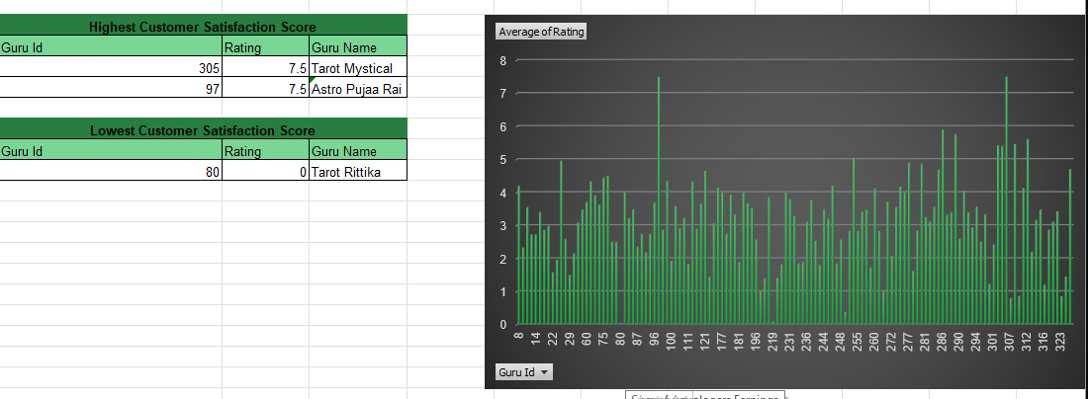

Question 13: What is the average customer satisfaction score by month?

Solution:

Final Answer (if any):
January has 2.67 average customer satisfaction score and December has 2.94
Approach (if any):
Used Pivot Table to summarize
Charts & Tables (if any):
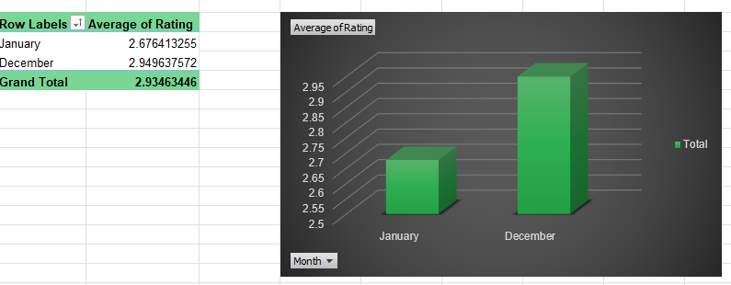

Question 14: How many categorical columns are there in the data? [Search about categorical and continuous data, and try to answer this question]

Solution:

Final Answer (if any):
Categorical data- 16
Approach (if any):
Manually counted the categorical and continuous data
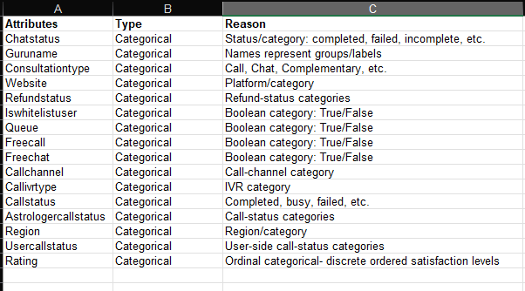

Charts & Tables (if any):
NA

SUBJECTIVE QUESTIONS

Question 1: Should the investment be used to hire more agents, improve training programs, or upgrade call center technology?

Solution:

Approach:
Created Pivot table and charts and separate table to analyze and highlight average rating of gurus, average call duration, failed and incomplete chat and call rate, call completion, busy, and no answer tickets.

Charts & Tables:
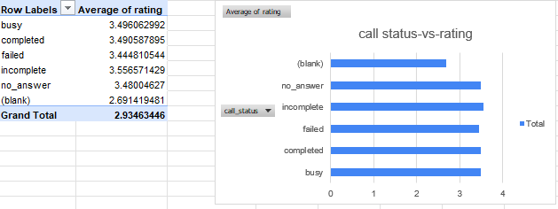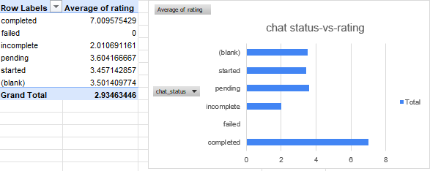
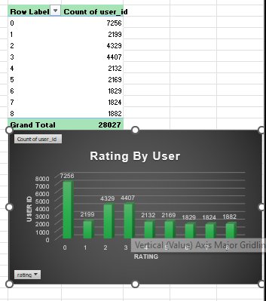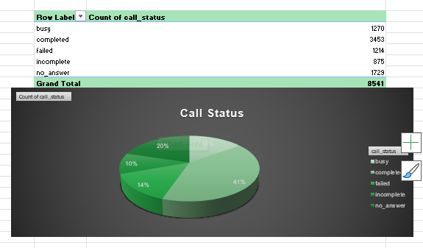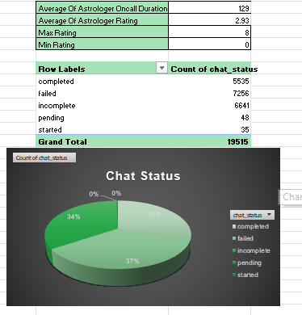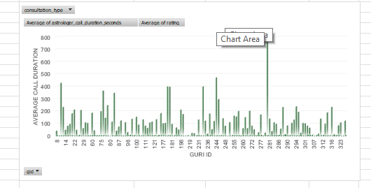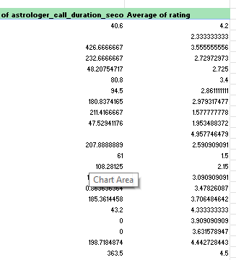

Insights:
Customer satisfaction is relatively low, with an average rating of 2.93 out of 8, indicating considerable scope for improving the overall customer experience. Average call duration is approximately 129 seconds (about 2 minutes). Out of 131 gurus, 41 (37%) have an average call duration above the overall average, while 70 (63%) are below it. This indicates that call engagement varies considerably across gurus and highlights an opportunity to understand why some gurus have shorter interactions. Chat outcomes show a significant service-completion issue: approximately 37% of chats failed and 34% were incomplete. These high unsuccessful/incomplete rates indicate that a substantial proportion of customer interactions are not reaching successful completion. Call availability is also a concern. Only around 41% of calls were completed, while approximately 35% were Busy or No Answer, suggesting that customers may be experiencing difficulty connecting with available gurus. The low overall rating combined with the high failed/incomplete interaction rates indicates a potential relationship between consultation outcomes and customer satisfaction. However, to establish this relationship more strongly, the average rating should be compared across Completed, Failed, and Incomplete consultations. Failed and incomplete consultations have lower average ratings than completed consultations, indicating that unsuccessful consultation outcomes are associated with lower customer satisfaction.
Recommendations:
Prioritize Agent Training - 50 Lakhs
Invest primarily in structured training programs focused on customer handling, consultation quality, resolution skills, and effective use of existing tools. The average customer rating is only 2.93/8, while 63% of gurus have an average call duration below the overall average of 129 seconds. The high failed and incomplete interaction rates also indicate a need to improve consultation handling and successful completion. Training should therefore be the first priority to improve customer experience and agent performance conducted to improve efficiency. Hiring: Hire more agents only if workload analysis shows a genuine need. The current issues like Busy, No Answer, low call completion, and short call durations are unlikely to be solved by adding more agents alone and may only increase operational costs.
Upgrade Call Center Technology- 30 Lakhs
Invest in technology improvements such as better chat systems, automated processes, call routing, and availability monitoring. Around 37% of chats fail, 34% are incomplete, and only 41% of calls are completed, while a significant share of calls are Busy or No Answer. Technology improvements can help reduce connection and process-related problems and support agents in delivering smoother consultations.
Hire Additional Agents- 20 Lakhs
Treat hiring as a targeted requirement rather than the first solution. Additional agents should be hired only where workload and availability analysis demonstrates a genuine capacity shortage. Since the current data shows significant Busy/No Answer and incomplete interactions, the underlying causes should first be addressed through training and technology improvements before substantially increasing headcount.

Question 2: What are the potential risks of each investment option (hiring, training, technology upgrades), and how can they be mitigated?

Name the chart/spreadsheet function you will use for solving the problem.

Solution:

Approach:
Evaluated the three investment options-hiring, training, and technology upgrades using the available Pivot Tables and supporting calculations. Reviewed daily call volume to understand workload, user-level call frequency to identify repeat-caller patterns, and average ratings by guru to assess customer satisfaction. These metrics were used to identify the potential risks associated with each investment option and determine appropriate mitigation strategies.
Functions Used:
Total Calls Made- =GETPIVOTDATA("[Measures].[Count of user_id]",$X$6)
Total Callers- =COUNT(Y7:Y3635)
Total 1 Time Callers- =AB5-AB7
Total Repeated Callers- =COUNTIF(Y7:Y3635,">1")
Total Repeated Calls- =AB4-AB6
Percentage Of Repeated Calls- =ROUND((AB7/AB5)*100,2)
Percentage Of Calls By Repeated Callers- Percentage Of Calls By Repeated Callers

Charts & Tables:
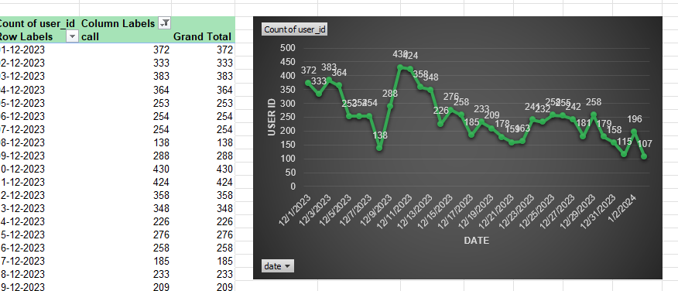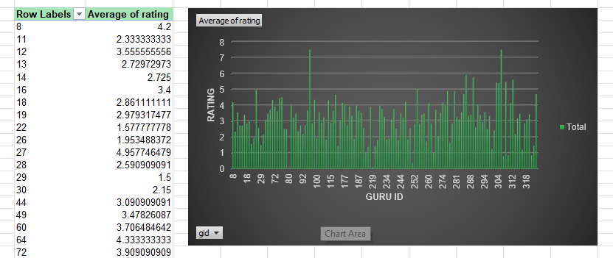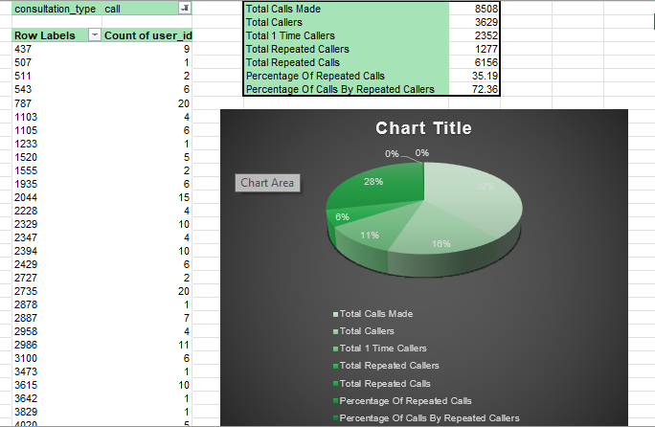
Insights:
Approximately 35.2% of callers are repeat callers (1,277 of 3,629), indicating meaningful recurring demand. However, repeat-caller behavior alone does not establish a staffing shortage, so hiring decisions should also consider call volume, peak workload and agent capacity. The overall average customer rating is approximately 2.93/8, indicating considerable scope for improving customer satisfaction. Therefore, increasing staffing alone may not be sufficient if the underlying customer-experience and service-quality issues are not addressed. The call-volume and consultation-status data also indicate operational challenges, including incomplete, failed, busy, and unanswered interactions. These create a risk that technology or staffing investments may not deliver their expected benefits unless the underlying operational problems are identified and monitored.

Recommendations:
Investment Risks & Mitigation
Training- Recommended First
- Risk: Training costs time and money and may not translate into performance improvements.
- Mitigation: Use call recordings to identify specific skill gaps and provide targeted training.
- Success measure: Improve the 2.93/8 average rating and reduce unsuccessful consultations.
Technology Upgrade- Second Priority
Risk: Technology investment may be expensive without solving the actual operational problem.
- Mitigation: Use phased pilots, SLAs, and performance monitoring before full deployment.
- Success measure: Reduce failed, incomplete, busy, and unanswered interactions.
Hiring- Third Priority
- Risk: Additional staffing increases costs without necessarily improving service quality.
- Mitigation: Use workload and call-volume data to identify genuine capacity shortages and use flexible staffing where possible.
- Success measure: Hire only when calls per agent consistently exceed the defined workload threshold.

Question 3: How does AstroSage's call center performance compare to AstroGuru's average call volume, customer satisfaction, and agent performance?

Will you use any aggregation function or a visualization here to solve the problem?

Solution:

Approach:
Calculated AstroSage's average call volume, customer satisfaction and agent performance using PivotTables and aggregation functions. Daily call counts were used to calculate average call volume, while average rating was used as the customer satisfaction measure. Agent performance was evaluated using call volume, average rating and average call duration. However, the AstroGuru dataset is not provided, so an actual numerical comparison between AstroSage and AstroGuru cannot be performed.
Spreadsheet functions/tools used:
PivotTable- summarize call volume, CSAT and agent performance by date, consultation type and user ID.
Counted the number of calls using CallSid using Pivot Table
Calculated average daily call- =AVERAGE(B12:B45)
Calculated average rating using Pivot Table

Charts & Tables:
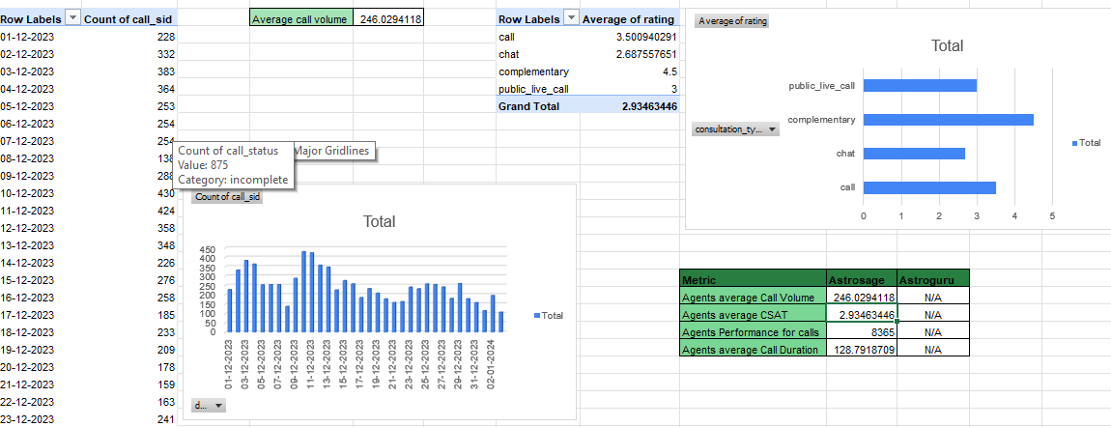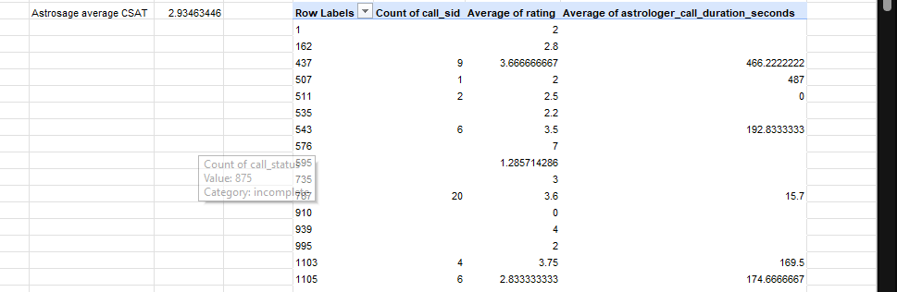
Insights:
AstroSage handled a total of 8,365 calls, providing a baseline for evaluating call-center workload.
The overall average customer satisfaction rating is approximately 2.93, indicating that there is considerable scope for improving customer satisfaction.
The average call duration is approximately 128.79 seconds, which provides a baseline for evaluating agent workload and handling efficiency.
Agent performance should be evaluated using calls handled, average customer rating and average call duration together, rather than relying on call volume alone. This helps identify differences in workload, customer satisfaction and handling intensity among agents.
AstroGuru data is not provided, so it is not possible to determine whether AstroSage performs better or worse than AstroGuru in average call volume, customer satisfaction or agent performance.
Recommendations:
- Obtain the AstroGuru dataset containing call volume, customer ratings and agent-level performance metrics so that a like-for-like comparison can be performed.
- Calculate the same KPIs for both AstroSage and AstroGuru using the same aggregation methods and definitions to ensure a fair comparison.
- Compare average call volume to identify which call center handles greater demand and whether additional capacity may be required.
- Compare average CSAT to identify which platform has stronger customer satisfaction and where customer-experience improvements may be required.
- Compare agent performance using calls handled, average rating and average call duration to identify workload imbalance, productivity differences and potential training requirements.
- Use the comparison results to prioritize staffing, training or technology investments toward the areas showing the largest performance gaps.
- Avoid making a final AstroSage-vs-AstroGuru performance conclusion until the AstroGuru data is available.

Question 4: How can the call center improve its handling of peak call periods to ensure high customer satisfaction?

Mention the functionality you will use for giving the suggestions, will it be any aggregated function or a visualization?

Solution:

Approach:
Used a Pivot Table to analyze call volume across 2-hour time intervals and identify peak call periods. Also analyzed average astrologer’s call duration by the same time intervals to understand workload intensity, while using the overall average customer rating to assess customer satisfaction. Functionality: Count Aggregation along with pivot and chart for visualisation.

Charts & Tables:
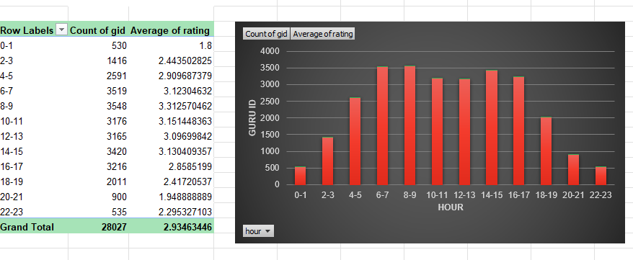
Insights:
The 08–09 time bin is the busiest period, with 3,548 calls, followed by other high-volume periods such as 06–07 and 14–15. This shows that call demand is concentrated in specific time windows. The overall average customer satisfaction rating is approximately 2.93/8, indicating considerable scope for improving customer experience. Call volume should be evaluated together with average call duration because a period with both high call volume and longer calls creates greater workload pressure on agents. Therefore, staffing should be prioritized based on both the number of calls and the time required to handle them.
Recommendations:
Prioritize staffing for the 08–09 peak: Allocate additional agent capacity during the 08–09 period, which handles 3,548 calls. Use flexible staffing for other peak periods: Adjust shifts and use peak-hour/flexible agents around the 06–07 and 14–15 high-volume periods. Align staffing with call duration: Use average call duration alongside call volume to identify the periods with the highest workload intensity. Improve call routing and callbacks: Use smart routing, IVR and callback options to manage demand during peak periods and reduce waiting times. Manage breaks strategically: Avoid scheduling large numbers of agent breaks during the highest-volume periods.

Question 5: Based on historical data, what strategic initiatives should be prioritized to improve efficiency and customer satisfaction?

Solution:

Approach:
Used PivotTables and charts to compare average customer ratings across consultation types and platforms. The analysis was used to identify the lowest-rated areas and prioritize improvement initiatives based on their potential impact on overall customer satisfaction and operational efficiency.
Total revenue by call- =GETPIVOTDATA("amount",$N$7,"consultation_type","call")/GETPIVOTDATA("amount",$N$7)
Charts & Tables:
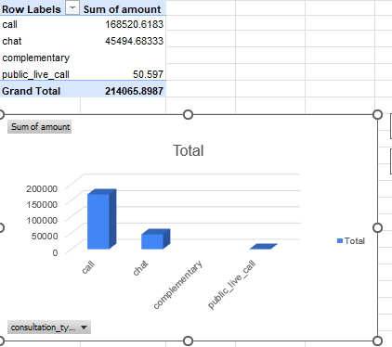
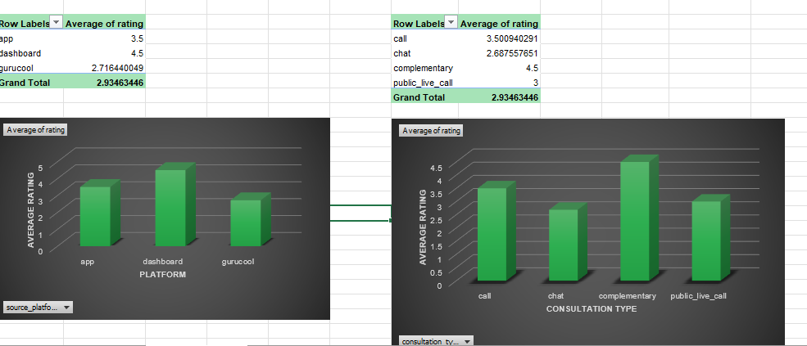
Insights:
Chat has an average rating of 2.69 compared with 3.50 for Call, making the Chat rating 0.81 points lower. Gurucool has an average rating of 2.72 compared with 4.50 for Dashboard, a difference of 1.78 points. These results indicate that Chat and Gurucool are the lowest-rated areas and should receive priority for customer-experience improvements. The Dashboard rating of 4.50 indicates relatively stronger customer satisfaction, while the lower ratings for Chat and Gurucool highlight areas where improvements could have a greater impact on overall customer satisfaction.

Recommendations:
Prioritize Chat improvements
Improve Chat reliability, response times, routing and handling of failed or incomplete interactions. The average Chat rating of 2.69 indicates that this is a major customer-satisfaction improvement area.
Improve the Gurucool experience
Investigate the causes of the low 2.72 average Gurucool rating and improve the platform experience, consultation process and customer journey.
Optimize the Call channel
After addressing the lowest-rated areas, continue improving the Call channel because it contributes approximately 79% of revenue. Use better call routing, staffing and technology to maintain service quality and protect this important revenue stream.
Monitor results
Track average ratings and completion rates by consultation type and platform after each improvement to determine whether customer satisfaction and operational efficiency are improving.

Question 6: What can be the key factors contributing to high customer satisfaction scores, and how can these be leveraged to improve overall performance?

What is the basis for the suggestions? And mention how you decided if the satisfaction score affects the ratings.

Solution:

Approach:
Used PivotTables to compare average customer satisfaction ratings across consultation types, platforms and interaction statuses. Call duration was also analyzed alongside average ratings to identify whether interaction length is associated with differences in customer satisfaction. Higher- and lower-rated groups were compared to identify potential factors associated with customer satisfaction, rather than assuming that one factor directly causes a higher rating. These comparisons were then used as the basis for the recommendations.
Charts & Tables: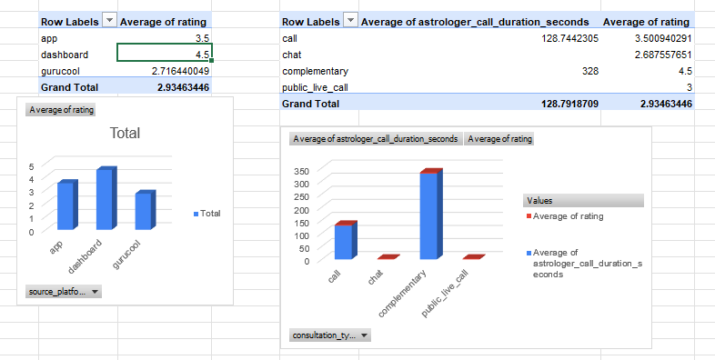
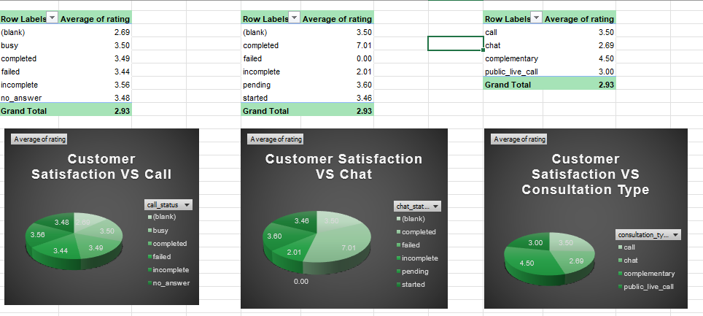
Insights:
Consultation type is associated with differences in customer satisfaction. Complementary consultations have the highest average rating of 4.50, compared with 3.50 for Call and 2.69 for Chat. Chat is therefore approximately 0.81 rating points below Call, indicating that the Chat experience is an important area for improvement. The higher rating for Complementary consultations provides a potential benchmark. The customer-handling practices used in higher-rated consultation experiences can be examined and, where appropriate, applied to lower-rated services. Platform-level ratings should be compared to determine whether the customer experience differs across App, Dashboard and Gurucool. Similarly, average call duration should be compared with average ratings to determine whether interaction length is associated with higher or lower satisfaction. The Chat-Completed average rating of 7.01 is unusually high compared with the overall average of 2.93. Although this is present in the data, it should be treated as a segment-specific observation and not as proof that completing an interaction causes higher satisfaction.

Recommendations:
Use high-rated experiences as a benchmark
Complementary consultations have the highest average rating at 4.50. Analyze the customer-handling practices associated with these higher-rated interactions and apply relevant practices to lower-rated consultation types.
Prioritize Chat
Chat has an average rating of 2.69 compared with 3.50 for Call. Therefore, Chat should be prioritized for improvement. Focus on response time, reliability, routing and unsuccessful/incomplete interactions.
Use platform analysis to target improvements
Compare average ratings across App, Dashboard and Gurucool and prioritize the lowest-rated platform. This allows improvements to be targeted toward the platform with the greatest customer-satisfaction gap rather than making broad changes without evidence.
Use call-duration analysis for workload improvement
Analyze call duration together with customer ratings to determine whether longer or shorter interactions are associated with different satisfaction levels. Use the results to improve agent allocation, staffing and customer-handling processes.
Monitor the results
After implementing improvements, compare the average rating and operational metrics again to determine whether customer satisfaction has improved.

Question 7: How should the call center balance the workload among agents to ensure optimal performance and avoid burnout?

Mention your approach and spreadsheet function for the answer.

Solution:

Approach:
Used a PivotTable to calculate the average call duration for each agent and compared it with the overall team average of 128.79 seconds to identify agents handling longer-than-average consultations. Call count and agent ranking were used as supporting measures to identify high-volume agents. The AVERAGE aggregation in the PivotTable was used to calculate average call duration, while RANK was used to identify agents with higher workload intensity.
Charts & Tables:
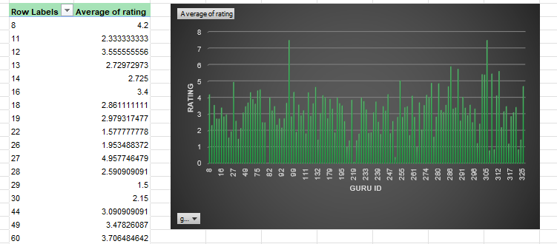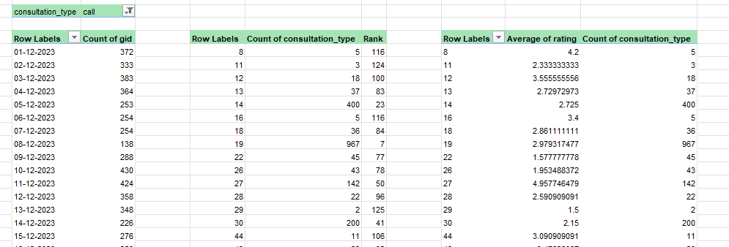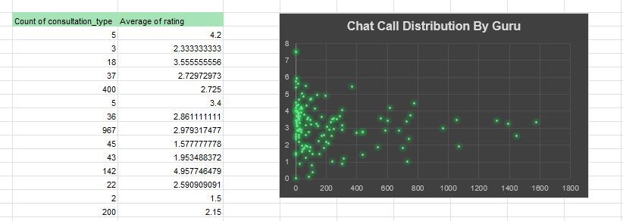
Insights:
The overall team average call duration is 128.79 seconds. Agents whose average call duration is substantially above this benchmark may be handling more time-intensive consultations and therefore have a higher potential workload/burnout risk. Call volume was also considered as a supporting measure because an agent handling both a high number of calls and longer-than-average calls is likely to face greater workload pressure. Therefore, workload should not be assessed using call count alone.

Recommendations:
Prioritize workload redistribution: First review agents with both above-average call duration and high call volume and redistribute suitable calls to agents with lower workload intensity.
Use flexible staffing: Adjust shifts and staffing during periods of high demand to prevent excessive workload on individual agents.
Manage breaks: Use staggered breaks for agents handling higher workloads to reduce burnout risk.
Provide targeted training: Review unusually long calls to identify whether training can help agents resolve consultations more efficiently without reducing customer satisfaction.
Monitor the 128.79-second benchmark: Regularly compare each agent's average call duration with the team average to identify changing workload patterns.

Question 8: What new technologies or tools could be implemented to enhance call center operations and customer service?

Solution:

Approach:
Evaluated potential technologies that can improve call-center efficiency, customer experience, agent productivity and operational monitoring. The analysis considered intelligent call routing and IVR, chatbots and self-service, CRM integration, Workforce Management (WFM), Technologies were prioritized based on their potential to reduce failed/incomplete interactions, improve response times, support agents and increase customer satisfaction.
Charts & Tables:
NA

Insights:
The existing performance data indicates opportunities to improve call and chat handling, customer satisfaction and operational efficiency. Since the overall customer rating is approximately 2.93, technologies that improve customer interaction quality should be prioritized. The high level of unsuccessful interactions also indicates potential benefits from intelligent routing, self-service and automated support.
A unified CRM can help agents access customer information more efficiently, while WFM can improve staffing based on demand patterns. Dashboards can provide management with real-time visibility into call volume, duration, status and customer satisfaction.

Recommendations:
Intelligent routing, IVR and self-service
Implement intelligent call routing, improved IVR and chatbots/self-service to direct customers to the appropriate support channel and reduce unnecessary agent workload.
Implementation: Start with the most common customer queries and gradually expand automation.
KPIs: Reduce failed/incomplete interactions, waiting time and repeat contacts.
Unified CRM
Implement or improve a unified CRM that provides agents with customer history, previous consultations and relevant information in one place.
Expected benefit: Agents can understand customer issues faster and provide more personalized support.
KPI: Reduce average handling time and repeat contacts while maintaining or improving customer ratings.
Workforce Management
Implement WFM tools to forecast call volumes and schedule agents according to demand patterns.
Expected benefit: Better workload distribution and reduced risk of agent burnout.
KPI: Reduce periods of understaffing/overstaffing and keep workload within defined limits.
Management dashboards
Develop real-time dashboards showing call volume, call duration, status, customer ratings and agent workload.
Expected benefit: Managers can identify operational problems quickly and make data-driven staffing decisions.

Question 9: What metrics should be included in the final dashboard to comprehensively view call center performance and guide investment decisions?

Solution:

Approach:
Reviewed the available PivotTables and dashboard charts and selected KPIs covering four key areas: customer satisfaction, operational efficiency, agent workload, and financial performance. Metrics were selected based on their ability to identify performance gaps, measure trends over time, compare consultation types and platforms, and determine where additional investment may be required. Daily and hourly metrics are used to identify workload and peak-period issues, while monthly and overall metrics are used to monitor customer satisfaction and financial performance.
Charts & Tables:
NA
Insights:
The overall average customer rating is approximately 2.93, indicating considerable scope for improving customer satisfaction. Chat has an average rating of 2.69, compared with 3.50 for Call, making Chat an important customer-experience improvement area. Platform performance also varies, with Dashboard averaging approximately 4.50 compared with approximately 2.72 for Gurucool, indicating a significant satisfaction gap. The average call duration is approximately 128.79 seconds. The 08–09 period has the highest call volume at 3,548 calls, with other high-volume periods including 06–07 and 14–15. This indicates that workload and staffing should be evaluated using both call volume and call duration. Call contributes approximately 79% of total revenue, making it the most financially important channel. Maintaining Call service quality is therefore important for protecting a major revenue stream.

Recommendations:
Customer Satisfaction- Highest priority
Metrics: Overall Average Rating/CSAT, Average Rating by Consultation Type, Average Rating by Platform.
Why it matters: These metrics identify where customers are least satisfied and whether the problem is concentrated in a particular service or platform.
Investment action: Prioritize training or customer-experience/technology improvements for consistently low-rated areas.
Current benchmark: Overall rating ≈ 2.93; Chat = 2.69; Gurucool = 2.72.
Operational Efficiency
Metrics: Total Calls, Completed Calls, Failed Calls, Incomplete Calls, Busy/No Answer and Average Call Duration.
Why it matters: These metrics show whether customers are successfully connecting with agents and how much time agents spend handling interactions.
Investment action: High failure/incomplete rates- investigate technology/routing. High workload- consider workforce management or staffing.
Current benchmark: Average call duration = 128.79 seconds.
Peak Workload
Metrics: Call Volume by Hour and Call Volume by Day.
Why it matters: These metrics identify when demand is highest and help prevent both understaffing and unnecessary staffing costs.
Investment action: Increase or redistribute agent capacity during consistently high-demand periods rather than hiring uniformly across all hours.
Current finding: The 08–09 period has 3,548 calls.
Agent Performance & Workload
Metrics: Calls per Agent, Average Call Duration per Agent and Average Rating per Agent.
Why it matters: These metrics identify workload imbalance and agents who may require additional support or training.
Investment action: Agents with above-team-average call duration and high call volume should be reviewed for workload redistribution; low-rating patterns can trigger targeted training.
Current benchmark: Team average call duration = 128.79 seconds.
Trends
Metrics: Monthly CSAT, call volume and revenue trends.
Why it matters: A single value cannot show whether performance is improving or deteriorating.
Investment action: Continue or adjust an investment based on whether the relevant KPI improves after implementation.

Question 10: How would you allocate a 1 crore rupee investment to optimize operational efficiency, enhance customer satisfaction, and boost profitability, and what analysis-based recommendations would you offer to support this?

[you have to give bullet pointers to answer this question]

Solution:

Approach:
  - Analyzed call/chat volume, peak hours, failed/incomplete interactions, agent workload, customer ratings and revenue contribution using PivotTables and dashboard metrics.
  - Identified the areas with the largest operational and customer-experience gaps.
  - Allocate the ₹1 crore toward the highest-impact areas: technology, training, operations/workforce management and analytics/monitoring.
  - Measured the impact of each investment using specific KPIs rather than investing without measurable targets.

Charts & Tables:
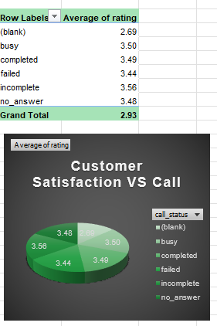
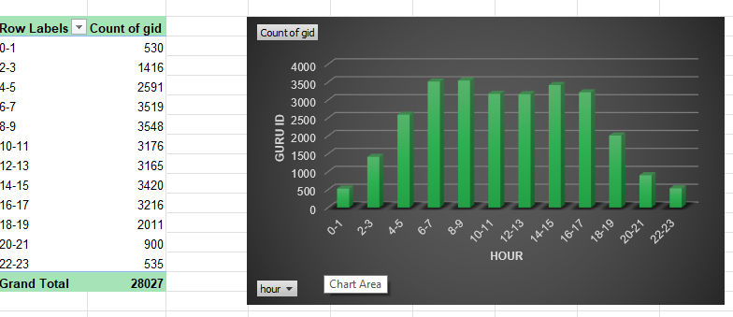
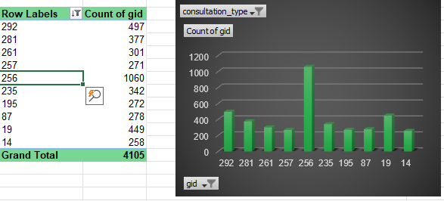
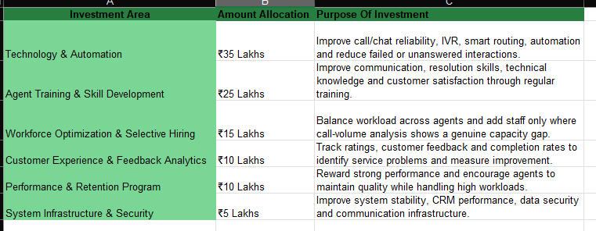
Insights:
- 53.8% of interactions (15,081 out of 28,027) occur between 06:00 and 14:00, indicating a strong concentration of workload during these hours.
- Agent workload is uneven, with some agents handling very high call volumes such as 1,580, 1,450 and 1,321 calls, indicating a potential workload imbalance.
- Chat has a major operational issue: 7,256 failed + 6,641 incomplete = 13,897 unsuccessful/incomplete chat interactions.
- Call also has 1,214 failed + 875 incomplete = 2,089 unsuccessful/incomplete interactions.
- Overall customer satisfaction is approximately 2.93, indicating considerable scope for improvement.
- Call contributes approximately 79% of revenue, so maintaining and improving the Call channel is important for protecting profitability.

Recommendations:
₹1 Crore Investment Allocation
Training- ₹50 lakh (50%)- Highest priority
- Allocate the largest share to targeted agent training because the overall customer rating is only 2.93, indicating considerable scope for improving customer satisfaction.
- Focus training on customer handling, issue resolution, communication and effective use of call/chat technology.
- Use call recordings, agent ratings and call-duration data to identify specific training gaps.
- KPIs: Improve average customer rating, reduce unnecessarily long calls and improve successful consultation rates.
Technology- ₹30 lakh (30%)- Second priority
- Upgrade chat systems, intelligent call routing, IVR, CRM and automation to address operational inefficiencies.
- This is particularly important because 13,897 chat interactions were failed or incomplete (7,256 failed + 6,641 incomplete).
- Implement technology in phases and monitor performance before expanding the investment.
- KPIs: Reduce failed/incomplete interactions, waiting time and average handling time while improving customer satisfaction.
Hiring- ₹20 lakh (20%)- Third priority
- Use the investment to add agent capacity only where workload data demonstrates a genuine requirement.
- 3.8% of interactions occur between 06:00 and 14:00, indicating that flexible staffing during peak periods may be more effective than adding agents uniformly.
- Prioritize workload redistribution and flexible/peak-hour staffing before expanding headcount significantly.
- KPIs: Reduce workload imbalance, peak-hour waiting time and excessive agent workload while maintaining customer ratings.

